Oracle Database Administration Services
Maximum sessions issue

Submitted to



By



CIS, Wipro Limited

Document Details

Project Name | Innogy SE
Account | CIS
IT Component/Application Title | Maximum sessions issue
Current Version | 1.5
List of Contributors | Jitenkumar Pansara,Saurabh Nigam,Abhishek Kansal, Sreya Puthukudy
Customer Contact Information

Version History
(All revisions made to this document must be listed in chronological order. All revisions must be approved. Review and Approval can be done by an internal source or by the customer)
Version | Date of Revision | Description | Author | Reviewed By | Approved By
1.0 | 27-07-2016 | Intial Draft | JitenKumar pansara | Saurabh Nigam | Mihir Gajjar
1.1 | 28-08-2016 | Document Completed | JitenKumar pansara | Saurabh Nigam | Mihir Gajjar
1.2 | 23-09-2016 | Updated document to standard format | Sreya Puthukudy | JitenKumar pansara | Mahesh Keshatwar
1.3 | 17-05-2017 | Wipro and Innogy Logo changed | Sreya Puthukudy | JitenKumar pansara | Mahesh Keshatwar
1.4 | 30-01-2018 | Updated document to Wipro Standard format with header and footer | Abhishek Kansal | JitenKumar pansara | Santosh Badiger
1.5 | 18-12-2018 | Updated the content | Sreya Puthukudy | JitenKumar pansara | Santosh Badiger

Table of Contents

1.
Short Description…………………………………………………….4
2. Problem Description…………………………………………………4
3. Root Cause…………………………………………………………...5
4. Solution………………………………………………………………5

Short Description:
ORA-0018 error, indicates that the fix is to increase the "processes" initialization parameter. To fix the ORA-00018 we increase the processes parameter, usually doubling the processes value to allow for future database growth.

Error Description:
ORA-00018.Maximum number of sessions exceed
Impact:
It will not allow new users to establish new connections
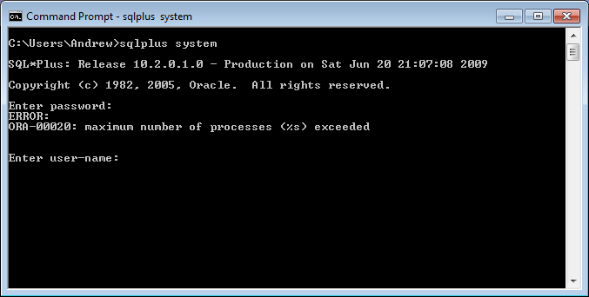
Workaround:
There are 2 ways to resolve the issue.
1. Update the processes parameter
a. Login to the server
b. ps -ef|grep pmon
c. Sqlplus "/ as sysdba"
d. shutdown immediate;
e. startup mount;
f. Alter system set processes=<New Number> scope=spfile;
g. alter database open;

2. Kill the sessions
a. kill -9 <process_id>
b. sqlplus "/ as sysdba"
c. select sid, serial# from v$session where status='ACTIVE';
d. alter system kill session '<sid>,<serial#>';

